|  |  |
| --- | --- |
|  | Use Cases |
|  |  |
| Generated 27.5.2020 г. | Rezervito |
|  |  |

Contents

Use Cases 2

UC-1 - View restaurant info 2

UC-3 - Admin Login 3

UC-4 - Manage user accounts 5

UC-5 - Report bugs to Development Team 6

UC-6 - Preorder food and drinks 7

UC-9-1 - Book table 9

UC-9-2 - Browse In restaurants catalog 11

UC-9-3 - Filter restaurants by categories 12

UC-9-4 - User Registration 13

UC-9-5 - See restaurants details 16

UC-9-6 - Subscribe to newsletters 17

UC-9-7 - Register through external site 17

UC-9-8 - Search restaurants by name 18

UC-10-1 - Add restaurant to Favorites 19

UC-10-2 - Give feedback 20

UC-10-3 - User Login 21

UC-10-4 - Report bugs 24

UC-10-5 - Login Through External Site 25

UC-11-1 - Check feedback 26

UC-11-2 - Edit restaurant info 27

UC-11-3 - Manager Login 29

UC-11-4 - Add newsletters 30

UC-11-5 - View reservations info 32

UC-11-6 - Generate reservations report 34

UC-12-1 - Restaurant Manager Registration 35

# Use Cases

### UC-1 - View restaurant info

#### Main Success Scenario

1. The Restaurant manager enters Rezervito
2. The Restaurant manager selects the option to view his restaurant (REQ-5-3.1)
3. The Restaurant manager gets access to his restaurant page

#### Extensions

1.a The Restaurant manager is logged in

1. Move to 2

1.b The Restaurant manager is not logged in

1. The Restaurant manager is prompted to sign in

2. Login in Rezervito (UC-11-3)

3. Move to 2

|  |  |  |
| --- | --- | --- |
| Related Requirements |  |  |
| REQ-5-3.1 | View Restaurant Information | Functional |

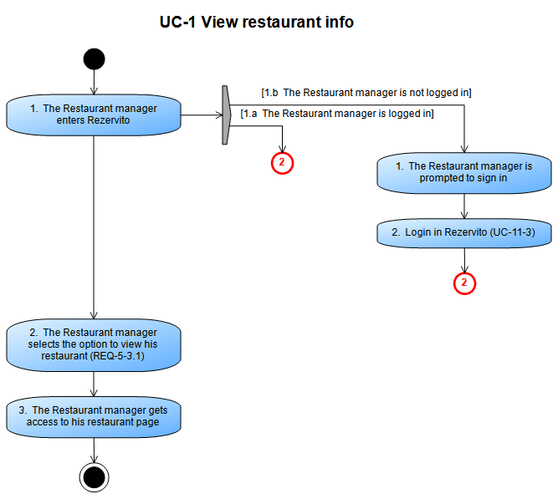

### UC-3 - Admin Login

#### Main Success Scenario

1. The System administrator enters Rezervito
2. The System administrator chooses to sign in (REQ-7-1)
3. The System administrator fills the login form
4. Rezervito validates the login form

#### Extensions

4.a Login credentials are valid

1. The System administrator is signed in

2. Ends

4.b Login credentials are invalid

1. The System administrator receives error notification

2. Move to 3

|  |  |  |
| --- | --- | --- |
| Related Requirements |  |  |
| REQ-7-1 | System Administrator Login | Functional |

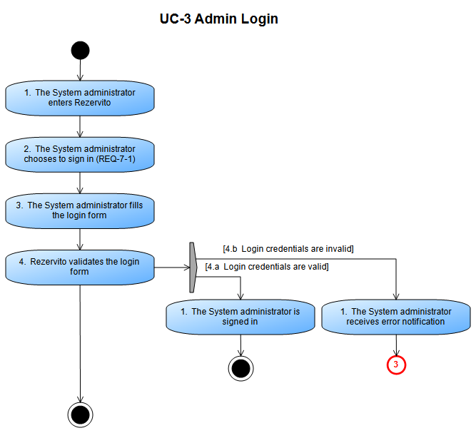

### UC-4 - Manage user accounts

#### Main Success Scenario

1. The System administrator logs in Rezervito (UC-3)
2. The System administrator selects the option to view user accounts
3. The System administrator views database containing user accounts
4. The System administrator chooses to add Restaurant manager (REQ-7-3) or remove user accounts (REQ-7-2)

#### Extensions

4.a Add Restaurant manager account

1. Restaurant Manager Registration (UC-12-1)

2. Ends

4.b Choose remove user accounts

1. The System administrator selects the user account

2. The System administrator selects the option to delete account (REQ-7-3.3)

3. Rezervito removes the user account from the database

4. Ends

4.c Choose edit user account

1. The System administrator selects the user account

2. The System administrator selects the option to edit account (REQ-7-3.2)

3. Rezervito updates the user account in the database

4. Ends

|  |  |  |
| --- | --- | --- |
| Related Requirements |  |  |
| REQ-7-2 | Manage Client Accounts | Functional |
| REQ-7-3 | Manage Restaurant Managers Accounts | Functional |
| REQ-7-3.1 | Create Restaurant Manager Account | Functional |
| REQ-7-3.2 | Edit Restaurant Manager Accounts by Admin | Functional |
| REQ-7-3.3 | Delete Restaurant Manager Accounts | Functional |

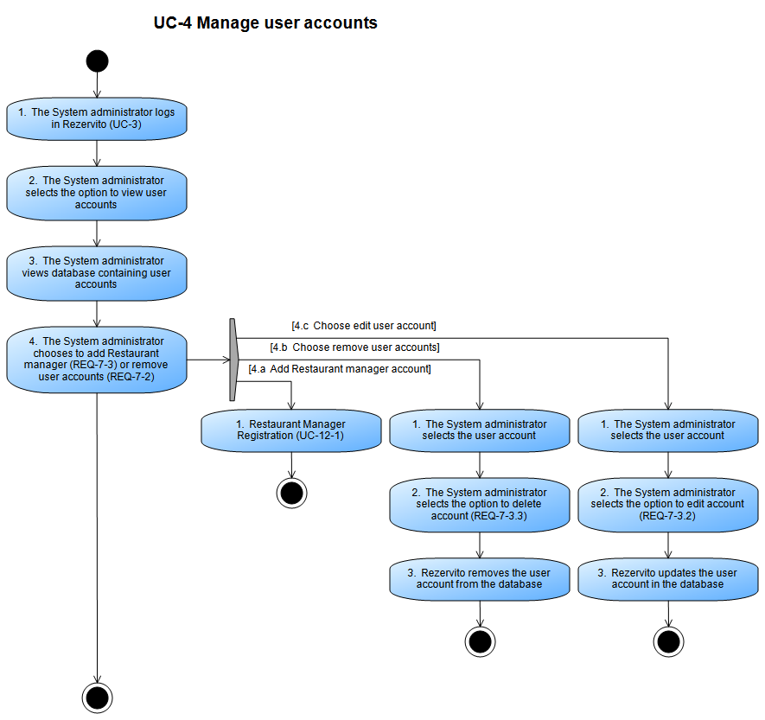

### UC-5 - Report bugs to Development Team

#### Main Success Scenario

1. The System administrator logs in Rezervito (UC-3)
2. The System administrator selects the option to view bugs
3. The System administrator views a list containing all reported bugs
4. The System administrator selects the option to report bugs (REQ-7-5)
5. The Development Team receives email containing info about the reported bugs

#### Extensions

|  |  |  |
| --- | --- | --- |
| Related Requirements |  |  |
| REQ-7-5 | Admin Report Bugs | Functional |

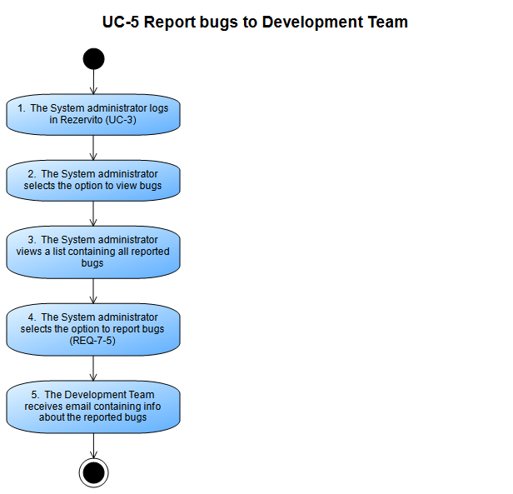

### UC-6 - Preorder food and drinks

#### Main Success Scenario

1. Book table (UC-9-1)
2. Registered user chooses to preorder food and drinks (REQ-5-9)
3. Registered user fills the preorder form
4. Rezervito processes the preorder form
5. Registered user receives success notification

#### Extensions

4.a Form information is valid

1. The cost of the preorder is subracted from the Registered user's banking account (REQ-5-9.1)

2. Move to 5

4.b Form information is invalid

1. Move to 3

|  |  |  |
| --- | --- | --- |
| Related Requirements |  |  |
| REQ-5-9 | Preorder Food and Drinks | Functional |
| REQ-5-9.1 | Pay For Preorder | Functional |

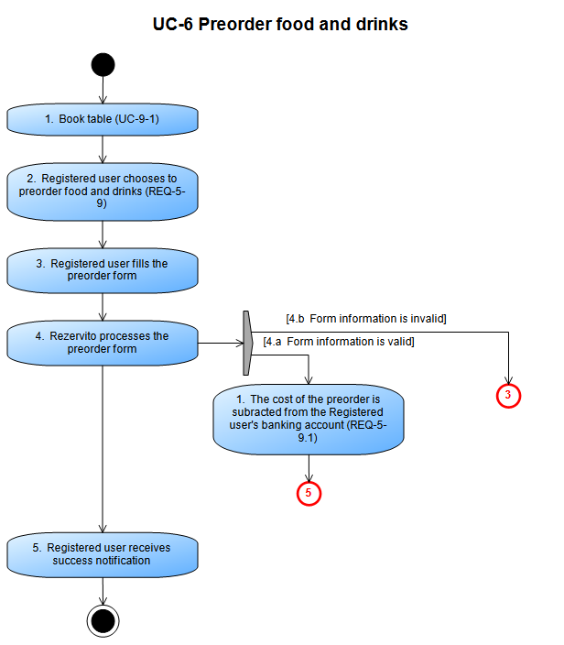

### UC-9-1 - Book table

#### Main Success Scenario

1. See restaurants details (UC-9-5)
2. User selects date and time (REQ-5-8.1)
3. User chooses number of attendees (REQ-5-8.2)
4. User selects which table they want (REQ-5-8.3)
5. Rezervito checks user type
6. User submits reservation
7. User receives notification

#### Extensions

5.a Unregistered user enters contact information

1. Reservation Contact information (REQ-5-8.4)

2. Move to 6

5.b Registered user chooses to preorder food and drinks

1. Preorder food and drinks (UC-6)

2. Move to 6

5.c Registered user doesn't preorder food and drinks

1. Move to 6

|  |  |  |
| --- | --- | --- |
| Related Requirements |  |  |
| REQ-5-8.1 | Reservation Date | Functional |
| REQ-5-8.2 | Reservation Size | Functional |
| REQ-5-8.3 | Reservation Preferred Table | Functional |
| REQ-5-8.4 | Reservation Contact information | Functional |

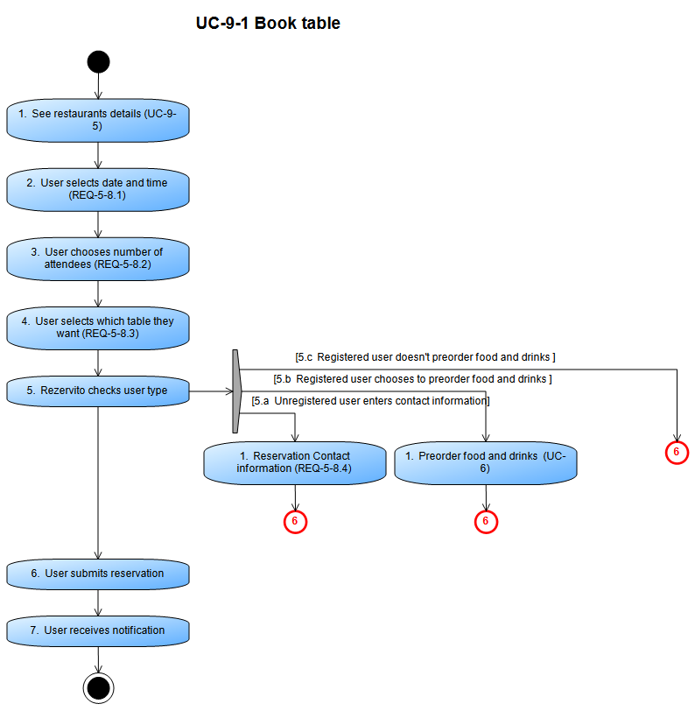

### UC-9-2 - Browse In restaurants catalog

#### Main Success Scenario

1. User opens the website
2. User chooses the restaurant catalog (REQ-5-3)

#### Extensions

2.a User filters the catalog

1. Filter restaurants by categories (UC-9-3)

2. Ends

2.b User selects a restaurant

1. See restaurants details (UC-9-5)

2. Ends

2.c User searches restaurants by name

1. Search restaurants by name (UC-9-8)

2. Ends

|  |  |  |
| --- | --- | --- |
| Related Requirements |  |  |
| REQ-5-3 | Browse Catalog of Restaurants | Functional |

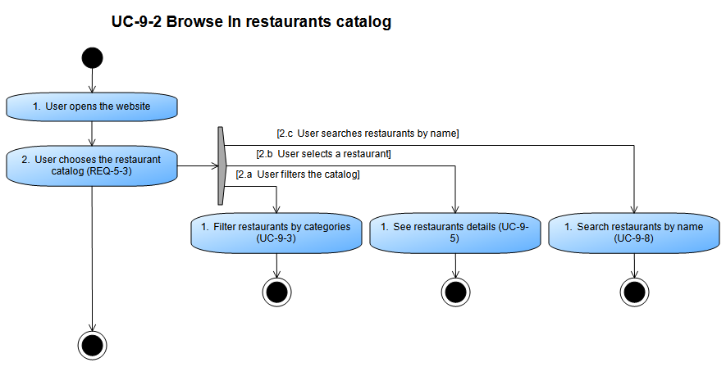

### UC-9-3 - Filter restaurants by categories

#### Main Success Scenario

1. Browse In restaurants catalog (UC-9-2)
2. User chooses how to filter restaurants (REQ-5-4)

#### Extensions

2.a Filter By Cuisine Type

1. Filter By Cuisine Type (REQ-5-4.1)

2. Ends

2.b Filter by Nearest Restaurants

1. Filter by Nearest Restaurants (REQ-5-4.2)

2. Ends

2.c Filter by Price

1. Filter by Price (REQ-5-4.3)

2. Ends

|  |  |  |
| --- | --- | --- |
| Related Requirements |  |  |
| REQ-5-4 | Filter Restaurant | Functional |
| REQ-5-4.1 | Filter By Cuisine Type | Functional |
| REQ-5-4.2 | Filter by Nearest Restaurants | Functional |
| REQ-5-4.3 | Filter by Price | Functional |

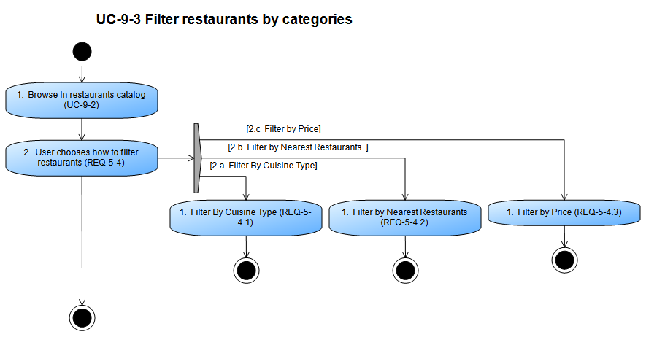

### UC-9-4 - User Registration

#### Main Success Scenario

1. Unregistered user enters Rezervito
2. Unregistered user chooses the registration button (REQ-5-1)
3. Unregistered user chooses how to register
4. Rezervito validates registration info
5. Unregistered user is informed of registration status

#### Extensions

3.a Unregistered user chooses to register through external site

1. Register through external site (UC-9-7)

2. Move to step 4

3.b Unregistered user chooses to register normally

1. Unregistered user fills the registration form

2. Move to step 4

4.a Registration is successful

1. Send email to user

2. Move to 5

4.b Registration is unsuccessful

1. Move to 5

|  |  |  |
| --- | --- | --- |
| Related Requirements |  |  |
| REQ-5-1 | User Registration | Functional |

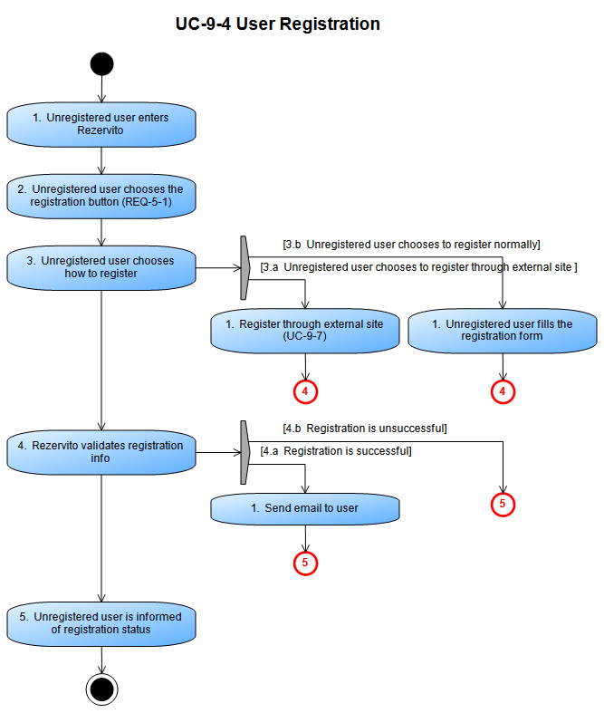

### UC-9-5 - See restaurants details

#### Main Success Scenario

1. Browse In restaurants catalog (UC-9-2)
2. User sees the restaurant's page (REQ-5-3.1)

#### Extensions

2.a User selects option to subscribe to newsletter

1. Subscribe to newsletters (UC-9-6)

2. Ends

2.b User selects option to make a reservation

1. Book table (UC-9-1)

2. Ends

2.c Registered user selects option to add restaurant to Favorites

1. Add restaurant to Favorites (UC-10-1)

2. Ends

2.d Registered user selects option to write a review

1. Give feedback (UC-10-2)

2. Ends

|  |  |  |
| --- | --- | --- |
| Related Requirements |  |  |
| REQ-5-3.1 | View Restaurant Information | Functional |

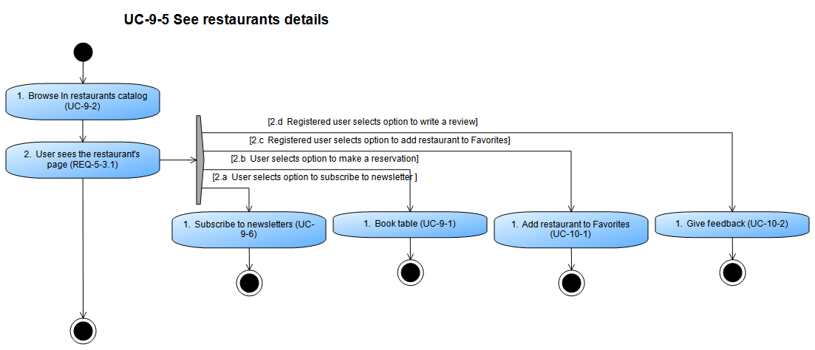

### UC-9-6 - Subscribe to newsletters

#### Main Success Scenario

1. See restaurants details (UC-9-5)
2. User enters email (REQ-5-7)
3. User receives notification

#### Extensions

|  |  |  |
| --- | --- | --- |
| Related Requirements |  |  |
| REQ-5-7 | Subscribe to Newsletters | Functional |

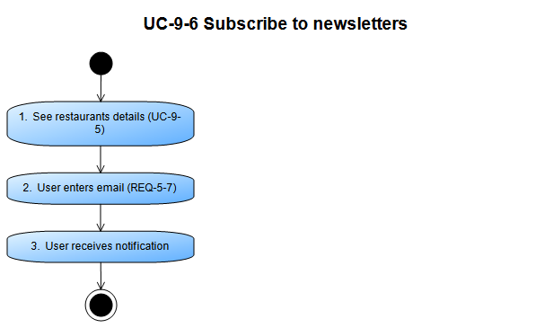

### UC-9-7 - Register through external site

Steps taken from "Register in Rezervito system " (UC-9-4)

#### Main Success Scenario

1. Register in Rezervito system (UC-9-4)
2. Unregistered user chooses to register through external account (REQ-5-1.1)

#### Extensions

2.a Select Facebook

1. Unregistered user registers through Facebook

2. Ends

2.b Select Google

1. Unregistered user registers through Google

2. Ends

2.c Select Twitter

1. Unregistered user registers through Twitter

2. Ends

|  |  |  |
| --- | --- | --- |
| Related Requirements |  |  |
| REQ-5-1.1 | Register Through External Site | Non-functional |

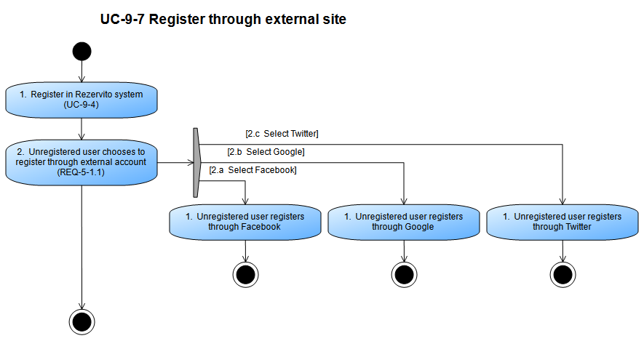

### UC-9-8 - Search restaurants by name

#### Main Success Scenario

1. Browse In restaurants catalog (UC-9-2)
2. User fills the search bar to search for restaurants in the catalog (REQ-5-5)
3. The catalog is updated to display restaurants matching the search bar

#### Extensions

|  |  |  |
| --- | --- | --- |
| Related Requirements |  |  |
| REQ-5-5 | Search Restaurants by Name | Functional |

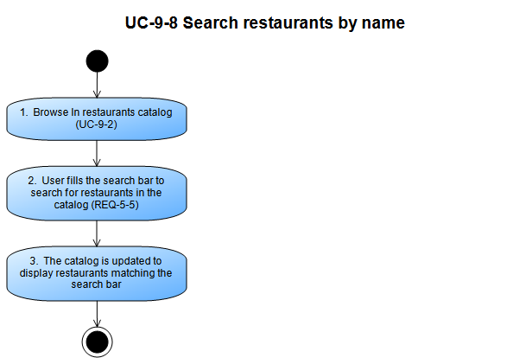

### UC-10-1 - Add restaurant to Favorites

#### Main Success Scenario

1. See restaurants details (UC-9-5)
2. Registered user selects the Add to Favorites option on the restaurant page (REQ-5-6)
3. The restaurant is added to his list of Favorites (REQ-5-6)

#### Extensions

|  |  |  |
| --- | --- | --- |
| Related Requirements |  |  |
| REQ-5-2 | User Login | Functional |
| REQ-5-6 | Add to Favorites | Functional |

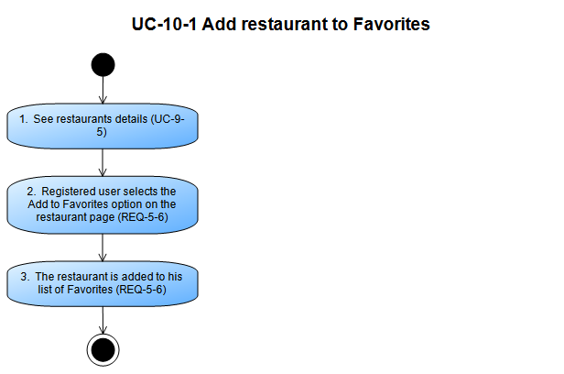

### UC-10-2 - Give feedback

#### Main Success Scenario

1. See restaurants details (UC-9-5)
2. Registered user selects the option to write a review (REQ-5-10)
3. Registered user selects a rating
4. Registered user writes in the text area
5. Registered user submits the review

#### Extensions

|  |  |  |
| --- | --- | --- |
| Related Requirements |  |  |
| REQ-5-10 | Give Feedback | Functional |

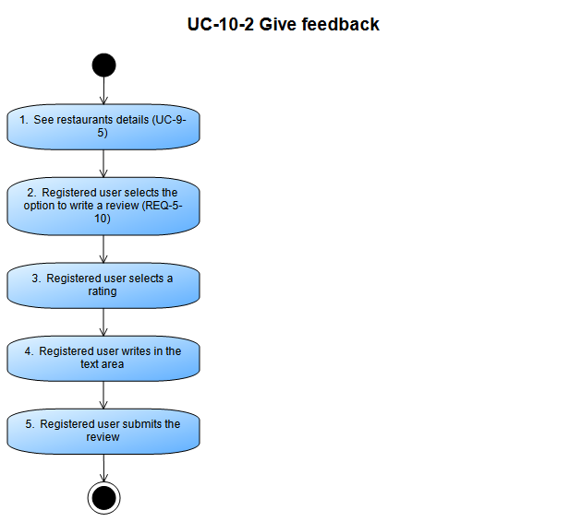

### UC-10-3 - User Login

#### Main Success Scenario

1. Registered user enters Rezervito
2. Registered user chooses the login button (REQ-5-2)
3. Registered user chooses how to login
4. Registered user fill the login form
5. Rezervito validates login info

#### Extensions

3.a Registered user chooses to sign in with a Rezervito account

1. Move to 4

3.b Registered user chooses to sign in with external account

1. Login through external site (UC-10-5)

2. Move to 4

5.a Login credentials are valid

1. Registered user is signed in

2. Ends

5.b Login credentials are invalid

1. Registered user receives error notification

2. Move to 4

|  |  |  |
| --- | --- | --- |
| Related Requirements |  |  |
| REQ-5-2 | User Login | Functional |

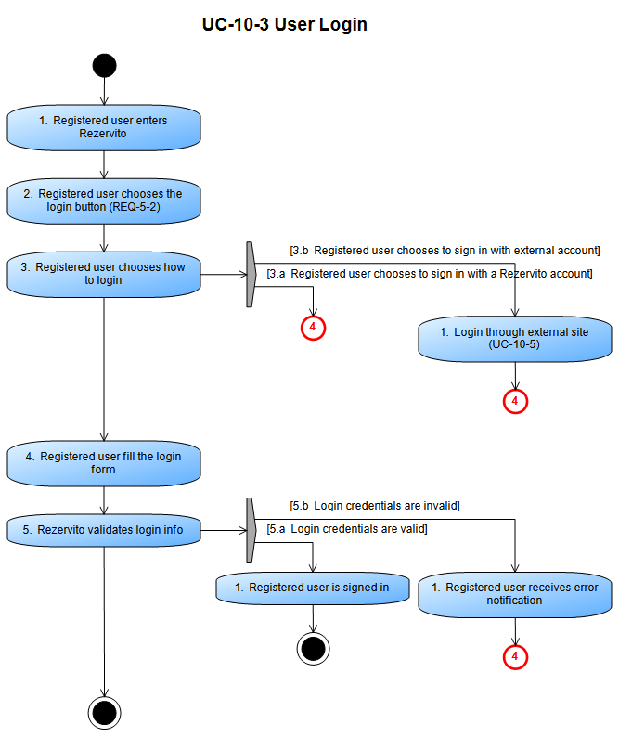

### UC-10-4 - Report bugs

#### Main Success Scenario

1. Registered user or Restaurant manager enters Rezervito
2. Registered user (REQ-5-11) or Restaurant manager (REQ-6-6) selects the report bug button
3. Registered user or Restaurant manager fills the report form
4. Registered user or Restaurant manager submits the report

#### Extensions

|  |  |  |
| --- | --- | --- |
| Related Requirements |  |  |
| REQ-5-11 | User Report Bugs | Functional |
| REQ-6-6 | Manager Report Bugs | Functional |

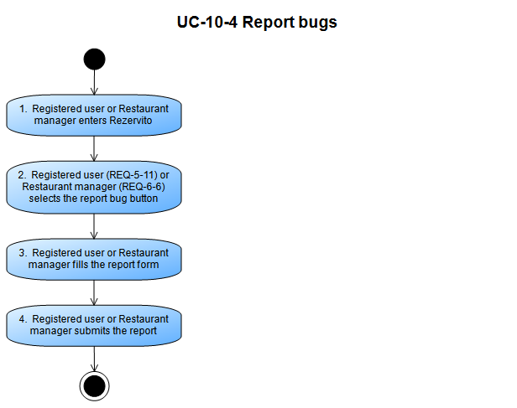

### UC-10-5 - Login Through External Site

Steps taken from "Login in Rezervito system " (UC-10-3)

#### Main Success Scenario

1. Login in Rezervito system (UC-10-3)
2. Registered user chooses external site to sign in from (REQ-5-2.1)

#### Extensions

2.a Select Facebook

1. Registered user signs in through Facebook

2. Ends

2.b Select Google

1. Registered user signs in through Google

2. Ends

2.c Select Twitter

1. Registered user signs in through Twitter

2. Ends

|  |  |  |
| --- | --- | --- |
| Related Requirements |  |  |
| REQ-5-2.1 | Login With External Account | Non-functional |

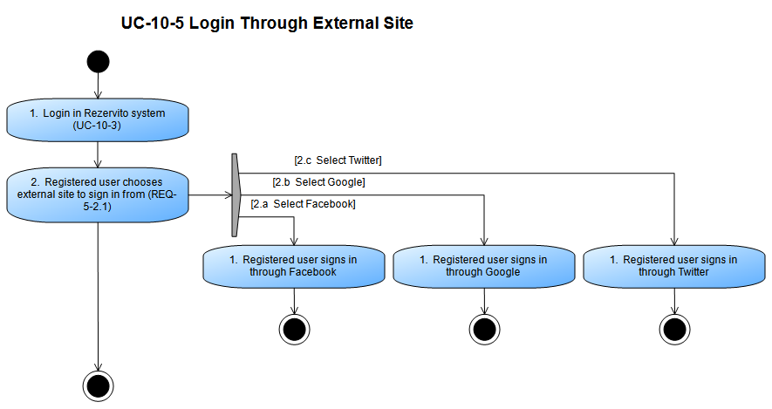

### UC-11-1 - Check feedback

#### Main Success Scenario

1. View restaurant info (UC-1)
2. The Restaurant manager selects the option to check feedback View feedback (REQ-6-3)
3. The Restaurant manager views a list of client reviews (REQ-6-3.1)

#### Extensions

|  |  |  |
| --- | --- | --- |
| Related Requirements |  |  |
| REQ-6-3 | View Feedback | Functional |
| REQ-6-3.1 | Feedback Information | Functional |

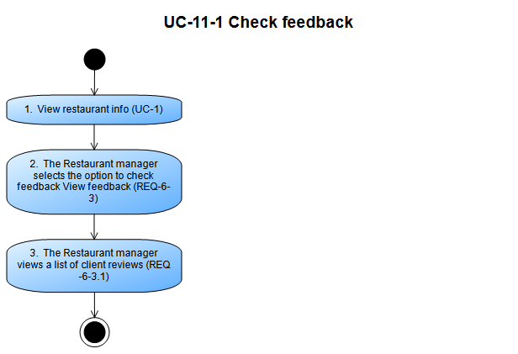

### UC-11-2 - Edit restaurant info

#### Main Success Scenario

1. View restaurant info (UC-1)
2. The Restaurant manager selects the option to edit restaurant info (REQ-6-4)
3. The Restaurant manager chooses what to edit (REQ-6-4.1)
4. The Restaurant manager changes the restaurant description
5. The Restaurant manager changes the restaurant address
6. The Restaurant manager changes the restaurant phone number
7. The Restaurant manager changes the restaurant work time
8. The Restaurant manager adds or removes photos from the photo gallery
9. The Restaurant manager adds or removes dishes from the menu

#### Extensions

|  |  |  |
| --- | --- | --- |
| Related Requirements |  |  |
| REQ-6-4 | Change Restaurant Information | Functional |
| REQ-6-4.1 | Restaurant Information | Functional |

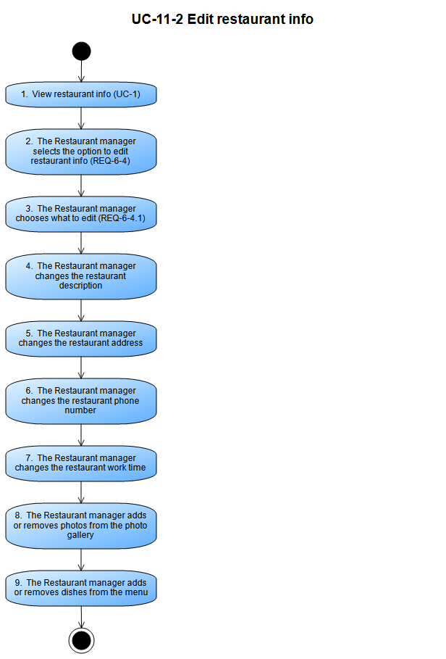

### UC-11-3 - Manager Login

#### Main Success Scenario

1. The Restaurant manager enters Rezervito
2. The Restaurant manager selects the option to sign in (REQ-6-1)
3. The Restaurant manager fills the login form
4. Rezervito validates the login form

#### Extensions

4.a Login credentials are valid

1. Restaurant manager is signed in

2. Ends

4.b Login credentials are invalid

1. Restaurant manager receives error notification

2. Move to 3

|  |  |  |
| --- | --- | --- |
| Related Requirements |  |  |
| REQ-6-1 | Restaurant Manager Login | Functional |
| REQ-6-8 | Generate report | Functional |

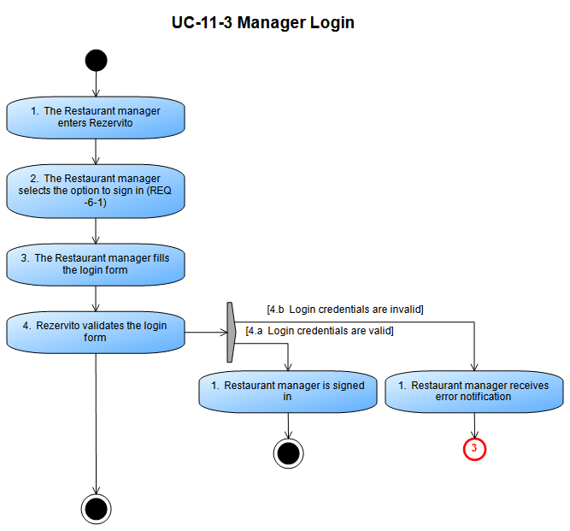

### UC-11-4 - Add newsletters

#### Main Success Scenario

1. View restaurant info (UC-1)
2. The Restaurant manager selects the option to update newsletter (REQ-6-7)
3. The Restaurant manager chooses how to update the newsletter
4. The Restaurant manager submit the new newsletter

#### Extensions

3.a Update through newsletter upload

1. The Restaurant manager chooses to upload a finished newsletter to Rezervito (REQ-6-7.2)

2. Move to 4

3.b Update through Rezervito newsletter template

1. The Restaurant manager fills the newsletter template (REQ-6-7.1)

2. Move to 4

|  |  |  |
| --- | --- | --- |
| Related Requirements |  |  |
| REQ-6-7 | Add Newsletters | Functional |
| REQ-6-7.1 | Create Newsletter | Functional |
| REQ-6-7.2 | Upload Newsletter | Functional |

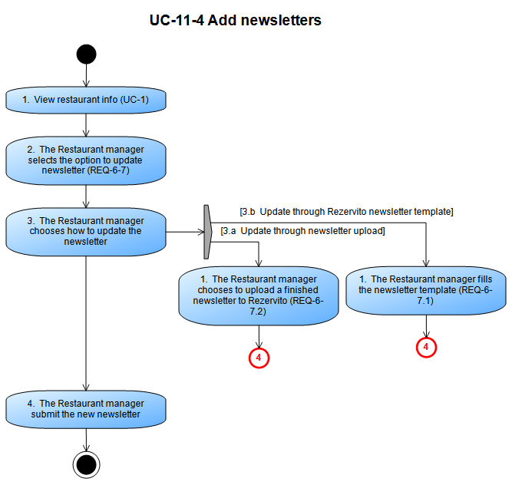

### UC-11-5 - View reservations info

#### Main Success Scenario

1. View restaurant info (UC-1)
2. The Restaurant manager selects the option to view reservations (REQ-6-2)
3. The Restaurant manager views the list of all reservations for his restaurant
4. The Restaurant manager selects a specific reservation
5. The Restaurant manager views the info for the reservation (REQ-6-2.1) (REQ-6-2.2) (REQ-6-2.3)

#### Extensions

|  |  |  |
| --- | --- | --- |
| Related Requirements |  |  |
| REQ-6-2 | Reservations Overview | Functional |
| REQ-6-2.1 | Check Client Details | Functional |
| REQ-6-2.2 | Check Reservation Details | Functional |
| REQ-6-2.3 | Check Preorder Details | Functional |

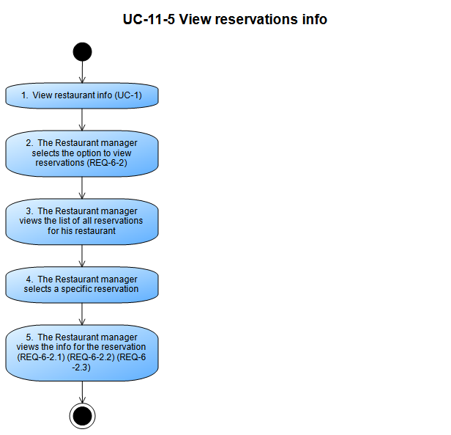

### UC-11-6 - Generate reservations report

#### Main Success Scenario

1. The Restaurant manager views his restaurant (UC-1)
2. The Restaurant manager selects the option to view reservations (REQ-6-2)
3. The Restaurant manager selects the option to generate a report (REQ-6-8)
4. The Restaurant manager selects the period of time to include in the report
5. Rezervito generates a report in PDF format

#### Extensions

|  |  |  |
| --- | --- | --- |
| Related Requirements |  |  |
| REQ-6-2 | Reservations Overview | Functional |
| REQ-6-8 | Generate report | Functional |

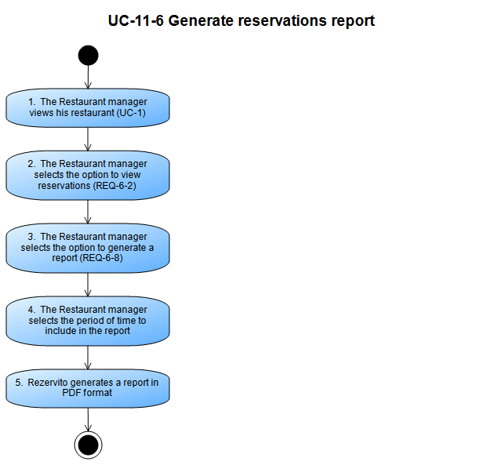

### UC-12-1 - Restaurant Manager Registration

Steps taken from "Manage user accounts" (UC-4)

#### Main Success Scenario

1. The System administrator receives a Restaurant manager registration form (REQ-7-3)
2. The System administrator fills the form (REQ-7-3.1)
3. Rezervito validates the form

#### Extensions

3.a Registration credentials are valid

1. The Restaurant manager account is created and added to the database

2. Ends

3.b Registration credentials are invalid

1. The System administrator receives error notification

2. Move to 2

|  |  |  |
| --- | --- | --- |
| Related Requirements |  |  |
| REQ-7-3 | Manage Restaurant Managers Accounts | Functional |
| REQ-7-3.1 | Create Restaurant Manager Account | Functional |

